William Harvey Research Institute
Work Experience Programme
July 2026

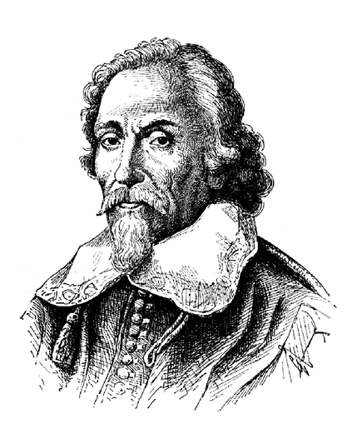


- The William Harvey Work Experience Programme is an in-person public engagement event that runs over two days at the William Harvey Research Institute, Faculty of Medicine and Dentistry, Queen Mary University of London in the 2nd half of July every year.
- The programme aims to provide an opportunity for sixth form students who are interested in studying Medicine or a Biological / Biomedical related degree at university and are considering a career in a similar field to gain first-hand experience in laboratory and clinical research.
- Application to the programme opens in May and the selected students are confirmed by the end of June.
- Approximately 30 students are hosted every year.
WHRI Work Experience Programme

Programme:

Day 1: Wednesday 29th of July

Time | Students | Activity | Staff
10:00 10:30 | All | Welcome and Introduction | Mohey Elshikh
10:30 11:00 | All | Imaging Human Tissues: From Organs to Cells | Mohey Elshikh
11:00 12:00 | All | Pharmacology and Innovative Therapeutics | Aisah Abdool
12:00 13:00 | All | Break
13:00 15:00 | All | Resuscitation And the Use of Automated External Defibrillators | Suzanne Mason
15:00 17:00 | All | Structure of the Normal and Rheumatoid Hand Arthritis Simulation Gloves. | Giorgia & Benedetta

Day 2: Thursday 30th of July

Time | Students | Activity | Staff
10:00 12:00 | All | Ultrasound Examination of the Hand | James Perera
12:00 13:00 | All | Break
13:00 15:00 | Rotating Groups  [G1 / G4] | EMR Lab Practicals [St = Station]  St 1: ELISA: HRP Activity [Anna]  St 2: IHC: MPO in The Lung Tissues [Federico]  St 3: Microscopy: Tonsil & Synovium [Manzoor]  St 4: Serology: Ag / Ab Interaction [Mohey] | Anna Willis  Lucas Jagemann  Manzoor Ahmed  Mohey Elshikh
   |  | St 1 | St 2 | St 3 | St 4
  12:30 | 13:00 | G1 | G2 | G3 | G4
  13:00 | 13:30 | G2 | G3 | G4 | G1
  13:30 | 14:00 | G3 | G4 | G1 | G2
  14:00 | 14:30 | G4 | G1 | G2 | G3
15:00 15:30 | All | Break
15:30 17:00 | All | Closure and Certificates | Mohey Elshikh

