Apply to switch/extend your student visa

From within the UK


The application form may be subject to change, please let us know if you notice any changes and we will update our guidance

Register an account

If you want to switch to a Student visa (i.e. you are currently holding a non-Student visa permission)
- Go to: Switch a Student visa

If you want to extend your Student immigration permission (i.e. you are currently holding a Student visa)
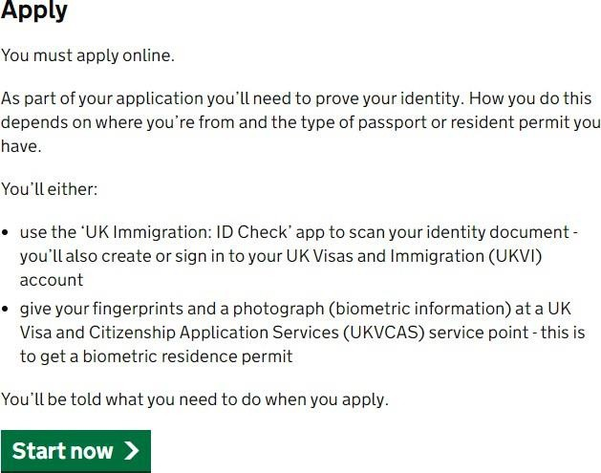
- Go to: Extend your student visa

Read carefully the information in this page and select ‘start now’

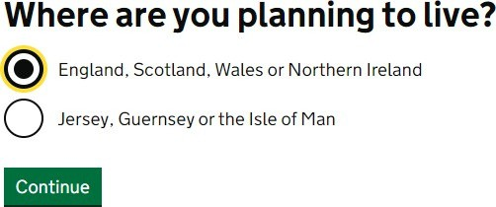
Please respond to where you plan to live by selecting ‘England, Scotland, Wales and Northern Ireland’
Select your answer depending on your nationality.

If you have an EU/EEA/Swiss passport and you answer ‘Yes’, then you will be led to instructions on how to complete your application using the ‘UK Immigration: ID Check’ app before completing the application form. If your passport does not have a biometric chip, you will be redirected to the application form and given instructions on how to submit your documents.

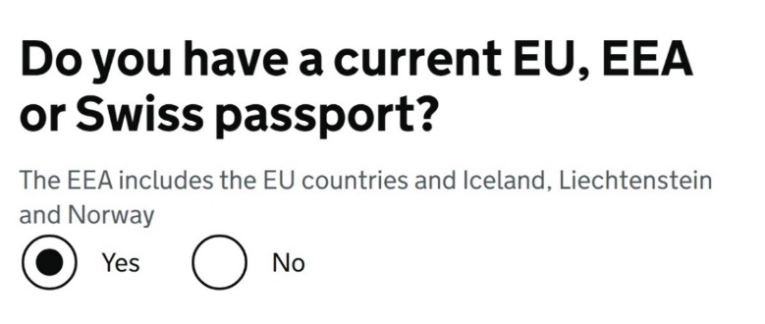 | 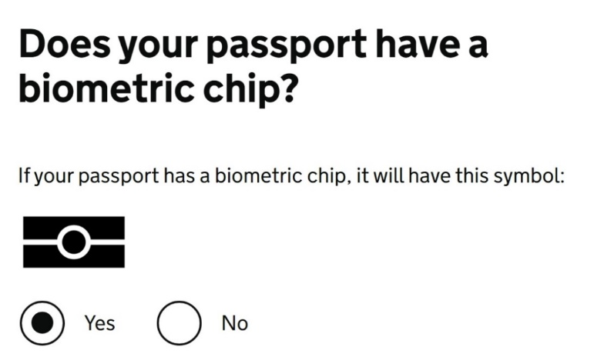

If you are not an EU, EEA, or Swiss, the following questions about BRP will follow. Answer ‘Yes’ if you have the document.
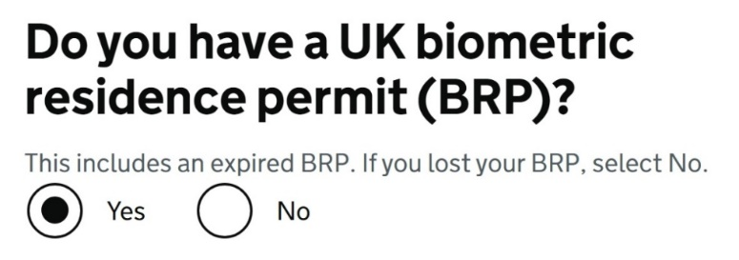

Please respond the questions accordingly. If your BRP has expired for 18 months or less and you select ‘Yes’ to the follow-up questions, you will be led to instructions on how to complete your application using the app.

If you select ‘No’ or your BRP has expired for more than 18 months, you will be redirected to the application form and given instructions on how to submit your documents.

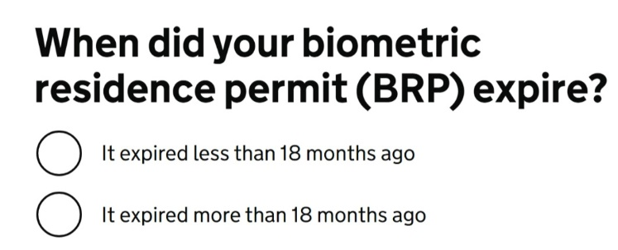 | 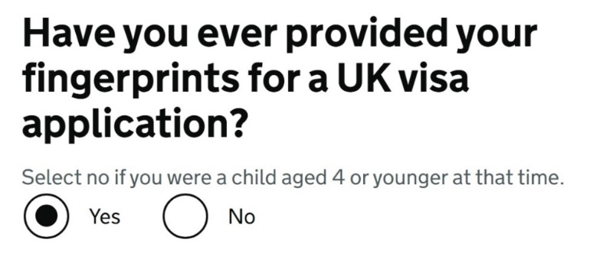  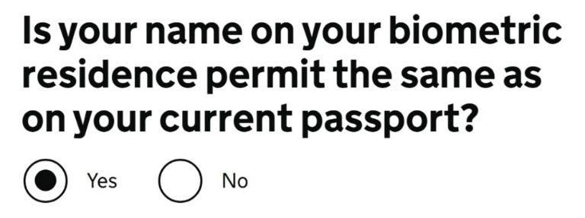

If your identity can be verified through the ‘UK Immigration: ID Check’ app, you will be required to verify your identity by downloading the app in your smartphone, we recommend read the guidance available to familiarise yourself with the process.

Please note, you will need to complete the identity verification first to be able to access the application form. If your identity cannot be verified through the app, the instructions to submit the biometrics will be outlined after making the payment of the application, in the next steps.

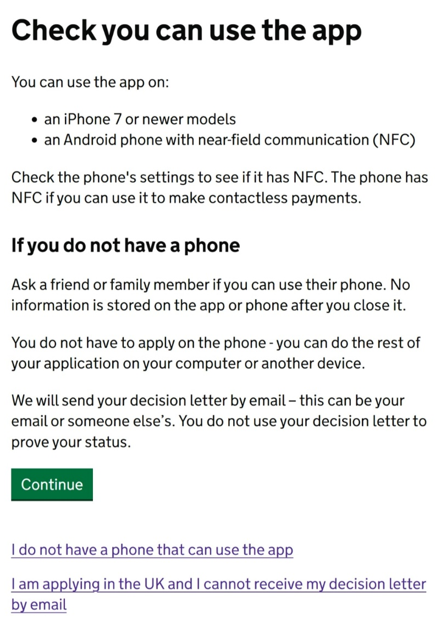 | 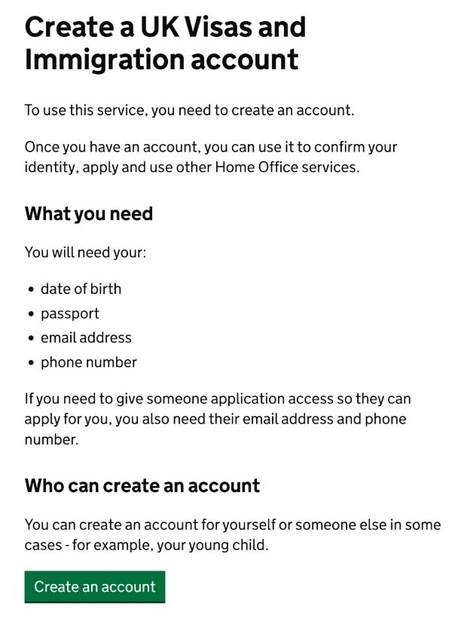

For all the other applicants, the following page includes information about the application process, fees, biometric information, and health surcharge read through it before selecting ‘Apply now’.
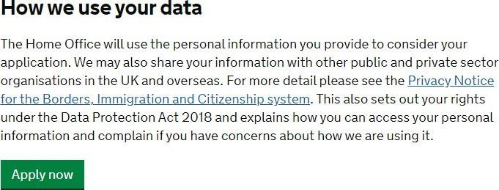

Answer the following questions:

- Are you currently in the UK? Select ‘Yes’
- If you currently have an application for leave to remain pending with the Home Office, contact Advice and Counselling; otherwise, select ‘No’
- Register your email – you should use the email account which you use most frequently.
- Do you have an immigration adviser? Select ‘No’ unless a solicitor or agent is helping you to complete the application form. Advisers at Advice and Counselling is not your immigration adviser.

Answer the questions, then check your answers and continue.

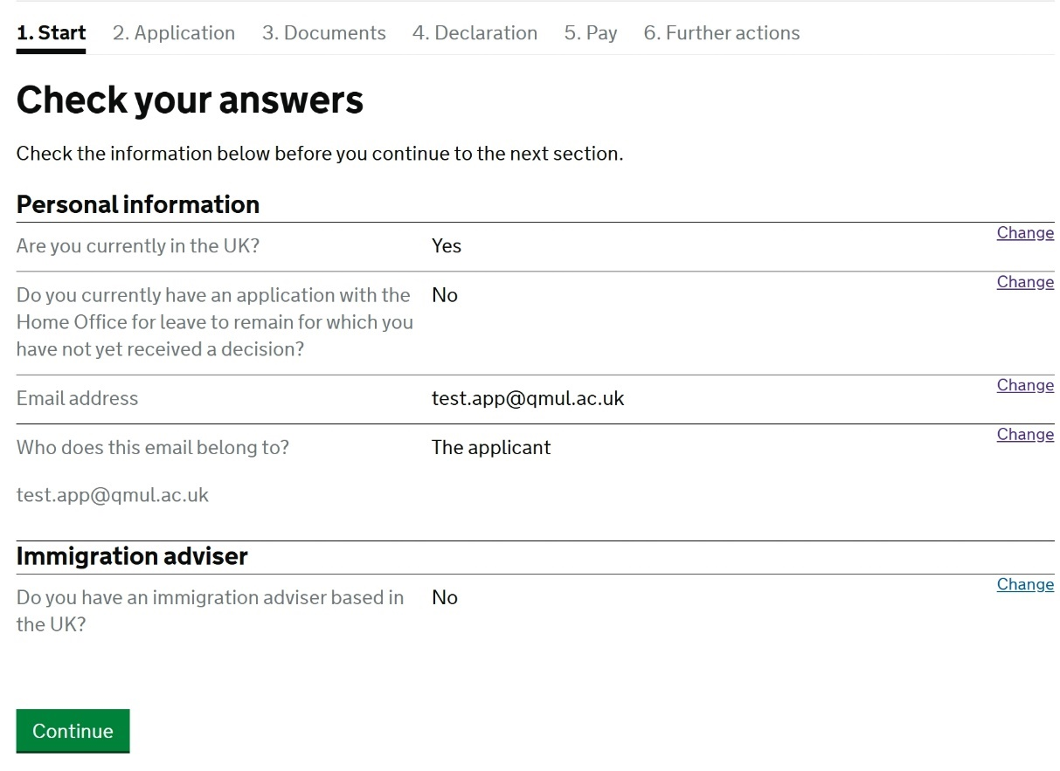

When you select ‘continue’, an email will be sent to the account used to create the application, you will need to verify the email to complete the visa application form.

Application Form

Answer all questions honestly and thoroughly according to your situation. We have explained some of the more difficult questions below.

Please note the questions in the application form may be different or in a different order depending on your circumstances or your previous answers on the form.

Name
Follow the instructions to answer questions about your name.

Telephone number
Give your telephone number if you have one.

UK Address
If you are planning to change address before you get a decision on your application, please check our guidance.

About the property
Respond this question accordingly, depending on your response, you will be asked further questions – for example the details of your landlord or your living arrangements.

Your gender and relationship status
Complete the details.

Nationality, country and date of birth
Complete the details as they are on your passport.

Passport
Confirm that you can provide your passport and complete the details as they are on your passport.

Biometric residence permit (BRP)

Permit number
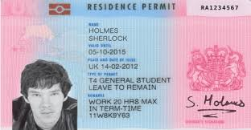

If you have a BRP card that has expired for 18 months or less, you should include the details as they are printed on your BRP.

Identity card
Please complete the details if you have another identity card. This includes identity cards, issued from non-UK governments. This does not include driving licenses. If you have an internal passport, provide the details here.

Other nationalities
If you have previously or still hold another nationality, then select ‘yes’ and complete the following details. If you have not, please select ‘No’ and continue.

Your current UK immigration status
Do you currently have a visa or leave to remain? Select ‘yes’ if have Student immigration permission,
Tier 4 immigration permission or another type of valid immigration permission which allows you to apply in the UK.

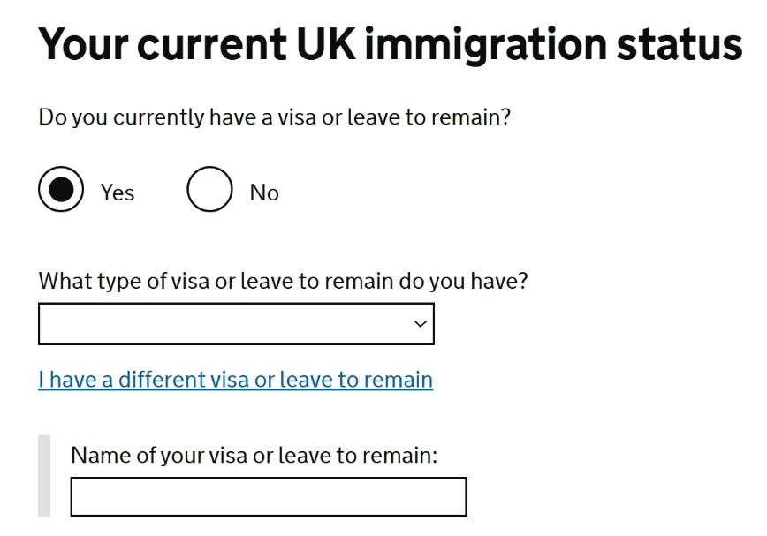

Revocation, cancellation or curtailment
If your immigration permission to enter or remain in the UK has ever been revoked, cancelled or curtailed, please select ‘yes’; otherwise you can select ‘no.’

Time in the UK
Please enter the number of years and months you have lived in the UK in total.

About your first parent
Complete the details using one of your parent’s details. It does not matter which one.

If you do not know their details, then click ‘What if I do not have my parent’s details?’ It will give a free text box where you can explain why you do not have their details.

About your second parent
Complete the details using your second parent’s details.

If you do not know their details, then click ‘What if I do not have my parent’s details?’ It will give a free text box where you can explain why you do not have their details.

National Insurance number
You will have a national insurance number if you have been working in the UK. Please enter the number here if you have one; otherwise select ‘I do not have a National Insurance number.’

Driving License
Only complete this if you have applied for and been issued with a UK driving license.

World travel history
Please select ‘yes’ if you have been to any other countries in the past 10 years that are not UK, USA, Canada, Australia, New Zealand, Switzerland or the European Economic Area.

If you have answered yes, then the following question will ask for details about where you have been in ‘Details of your world travel history.’ Which will ask you the countries you visited, the reason and dates of entry and departure.

If you have not been in any of the countries listed, you can select ‘No’

Evidence of English requirement
You can check your CAS to confirm how your English language level was assessed.

In most cases your Higher Education Institution has made assessment, so you would choose that option and you do not need to provide evidence of this if studying at degree level or above at QM for your visa application.
If your CAS says that your English language has been assessed in another way, select ‘No’ and
answer the following questions according to your situation. Most students would find that they answer ‘Yes’ to the question below.
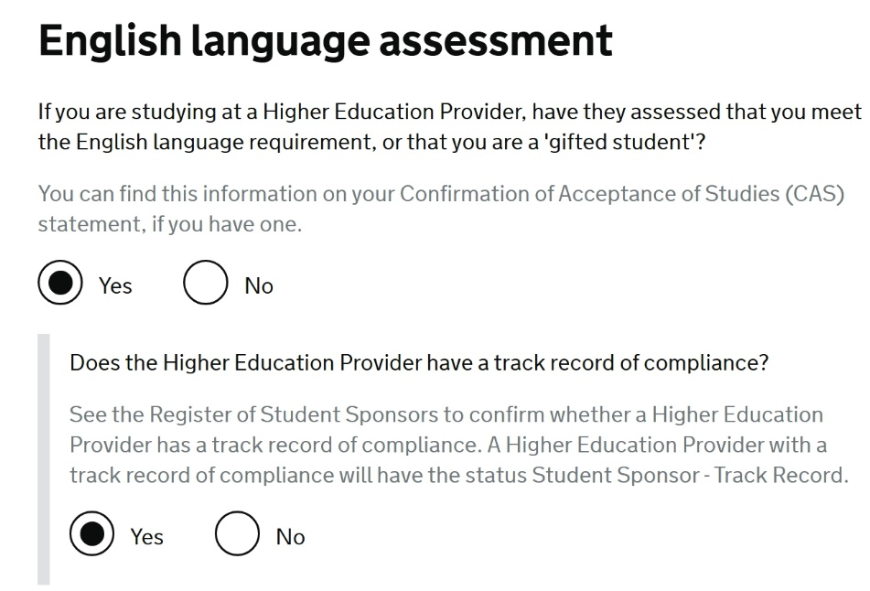

Check your CAS to see how your English level has been assessed:
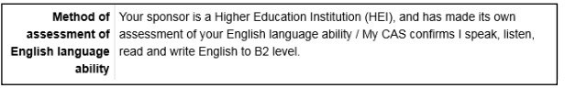

Immigration history
Please complete the details. If you have not been subject to any of the actions listed select ‘No’. If you have, then select ‘Yes’ and answer the following questions.

Breach of UK immigration law
Please complete the question.

Medical treatment in the UK
Please complete the details about any medical treatment you have received in the UK and answer the questions that follow.

Public funds
Usually, one of the restrictions of being on a Tier 4 or Student visa is that you are not entitled to public funds (this is referring to things like benefits) so you would normally select ‘No’.

If you have received public funds, please select ‘Yes.’

Convictions and other penalties
Please complete the question.

War crimes
Please complete the question. There is guidance to help with your understanding of war crimes, please read the information and tick to confirm you read it.

Terrorist activities, organisations and views
Please complete the question. There is guidance to help with your understanding of terrorist activities, organisations and views, please read the information and tick to confirm you read it.

Extremist organisations and views
Please complete the question. There is guidance to help with your understanding of extremist organisations and views.

Person of good character
Complete the question. If you select ‘Yes’, you will have to provide more details.

Employment history
Please complete the question.



Please refer to your CAS to respond the course information questions.

Sponsor license number and address
What is your sponsor license number? Write: 11W8K9Y63
Sponsor’s address Write: Queen Mary University of London, 327 Mile End Road, London, E1 4NS.

Place of Study
Select Higher education institution with a track record of compliance (Note this is important so please pay close attention to select this choice).
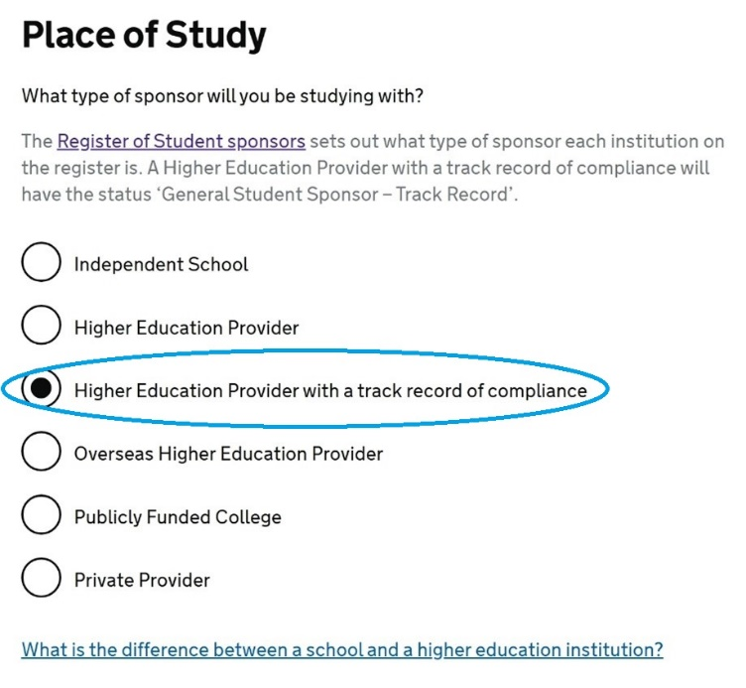

Primary place of study
Choose ‘Yes’ if this will be your primary place of study. If not, then please select ‘No’ and complete the details.

UCAS details
Please complete the question.

Academic Technology Approval Scheme (ATAS)
Please complete the question. For further information about ATAS, please see our guidance.

Current or past official financial sponsor
Are you currently receiving money from an official financial sponsor - or have you received money from an official financial sponsor in the past 12 months? If you are not sure, then please see the information in the link on the application ‘What is an official financial sponsor’ or in our guide about Official financial sponsor.

Future official sponsor
Please complete the question. If you select ‘Yes’, you will be asked further questions about your official financial sponsor.
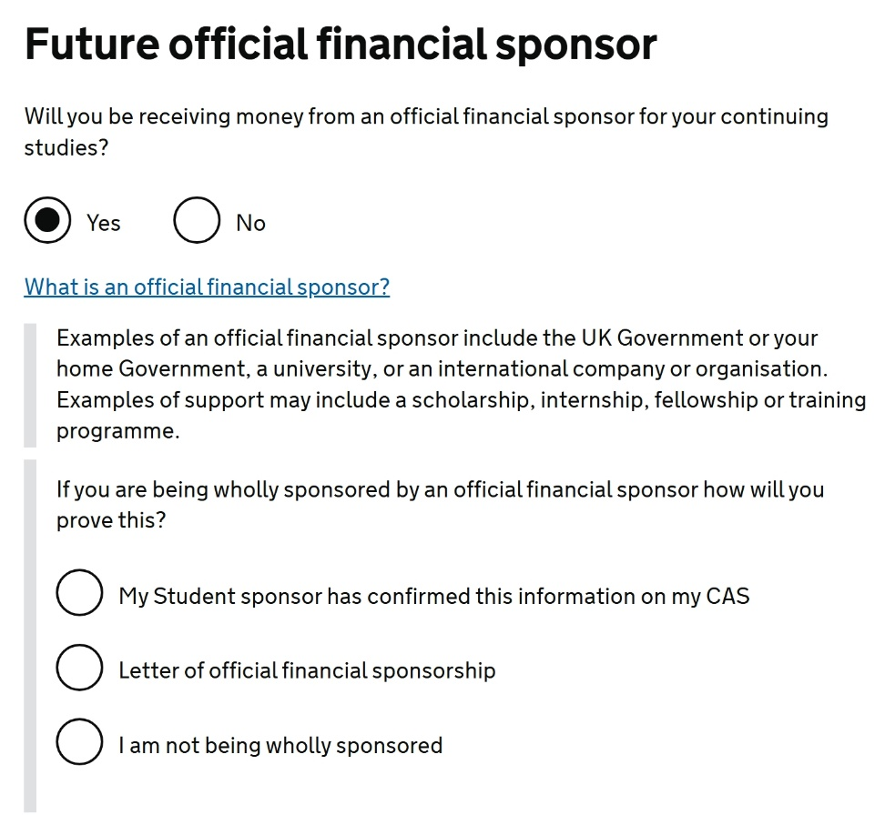

Course information
Please complete the information about your course from your CAS.

Note for the qualification you will get – This is the RQF level (for England) of your course, not SCQF (which is a separate academic framework used in Scotland).

*Your CAS may state NQF, instead of RQF. This is just a renaming of the academic framework but the levels are the same. For example, if your CAS sates the academic level of your course being NQF 7, select on the visa application form RQF level 7.

Course dates
Please copy these from your CAS.

Accommodation
Please answer the question. Note it is only if you have paid money (excluding deposit) for your accommodation to your sponsor, which is Queen Mary University of London. See our guidance on Funds for your Student visa application.

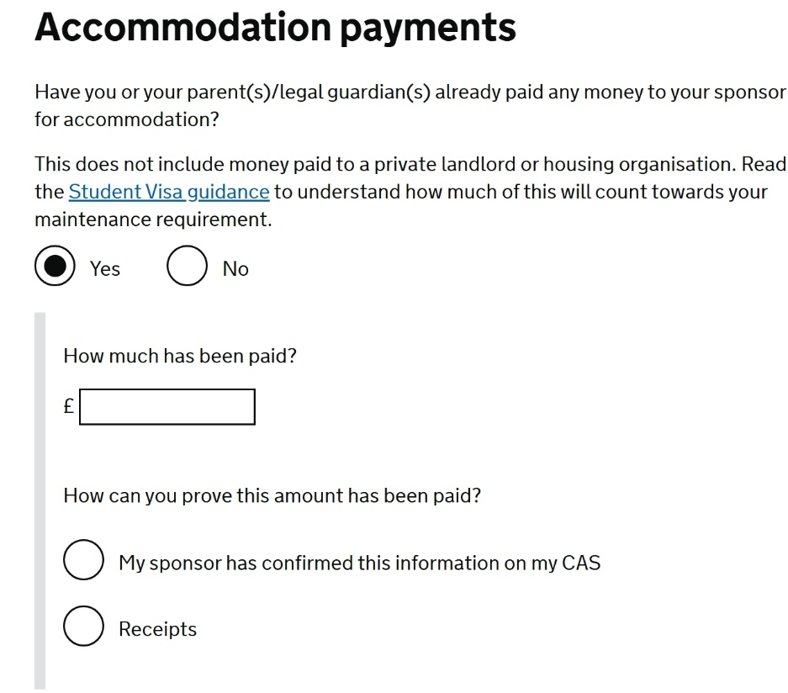

Course fees
Please copy this from your CAS. If you have already paid your fees, complete the following questions and confirm ‘My sponsor has confirmed this information on my CAS’.

If your CAS has not been updated to show that you have paid fees, then please contact CAS-Admissions@qmul.ac.uk if you are a new student at Queen Mary or contact casinfo@qmul.ac.uk for continuing students.

Student loan
Please complete the question.

Maintenance funds
Are all of the maintenance funds required for this application in a bank account with your name on it? If you are required to show funds, then please complete the question based on your situation. Please refer to our Funds for your Student visa application page for guidance.

Are you relying on money held in an account under your parent(s) or legal guardian(s) name?
Please respond according to your circumstances, if you respond ‘Yes’ to the above question, the following will apply, please respond according to your circumstances.

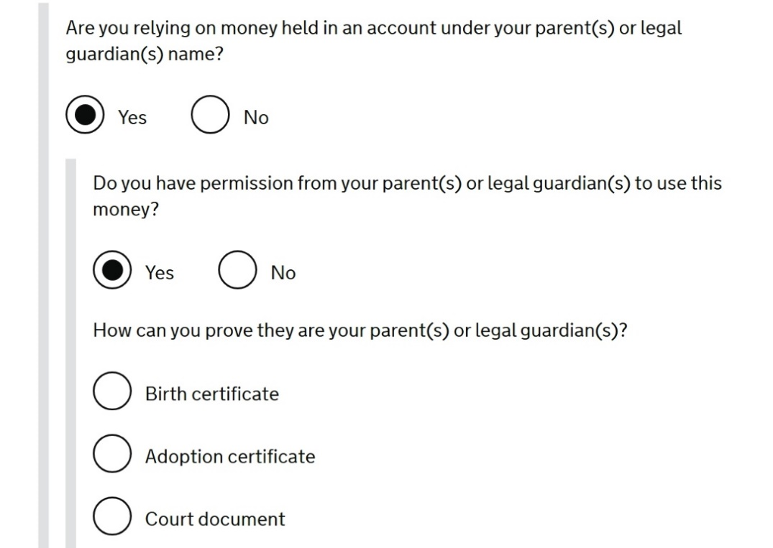

Do you have permission from your parent(s) or legal guardian(s) to use this money? Please note, if the funds are not in your personal account, you would require permission from the account owner, please read our carefully our Funds for your Student visa application guide.

How can you prove they are your parent(s) or legal guardian(s)? Respond to this question based on your evidence you will provide later on along with the submitted visa application.

NOTE: You will automatically meet the financial requirement if you are making the new visa application from inside the UK and you have been in the UK for at least 12 months with valid immigration permission on the date of application. None of these questions will appear if you fit this exemption.

Your Confirmation of Acceptance of Studies (CAS)
Please complete the details as shown in your CAS.

You will then have the opportunity to check and edit answers about the applicant.

Dependants
At this point, you can add a dependant child/spouse/partner if you are eligible to do so.

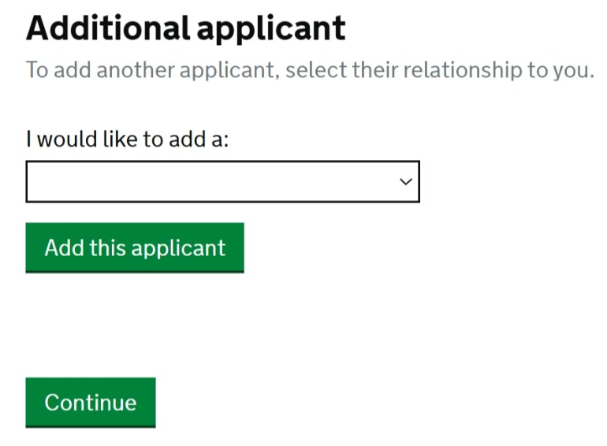
If you don’t have dependants to include in your application, choose ‘continue’.

Documents
Select all the documents you will include with your application. You will upload the documents in the next steps and take your original passport to your appointment.
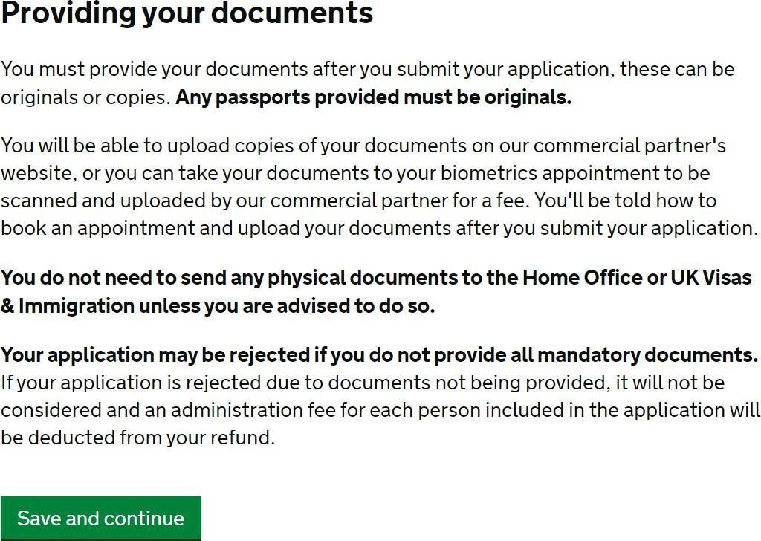

Differentiation Arrangement
If you are a national of a country that qualifies under the differentiation evidence arrangement, you
must still meet the Student visa requirement but only need to provide evidence of your funds and qualifications if requested to do so by UKVI.

Declaration
To complete this part of the application, please verify your email through the link sent to the account used to create the application at the start of the process. If you already verified your email, you will be asked to sign the declaration.

Pay
There are two payments embedded in the application which must be paid in full to be able to submit the application – the Immigration Health Surcharge (IHS) and the visa application fee.
After signing the declaration, you’ll be directed to pay for the IHS.
Please note, once you have clicked ‘pay now’ and have been directed to the IHS payment page, your visa application form will be locked and you’ll no longer be able to amend your responses. Please take time to check your answers before completing this part of the process.

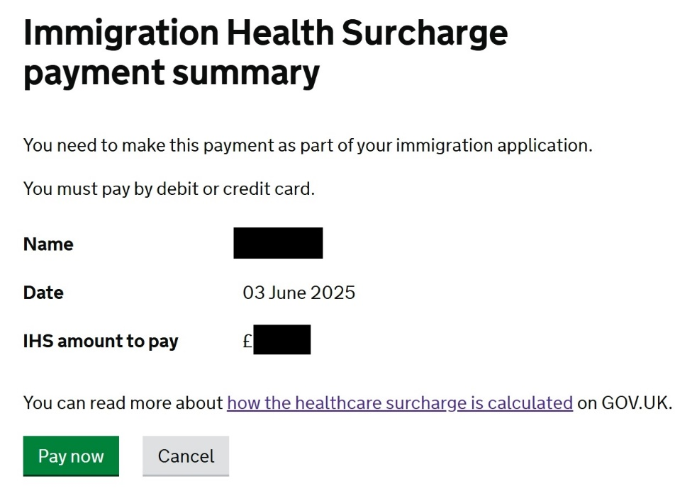
After paying the IHS, you will be redirected to pay the application fee, find out the visa application fee on our website.

Submitting your application
Once you have completed the visa application form and paid the fees, your visa application is submitted.

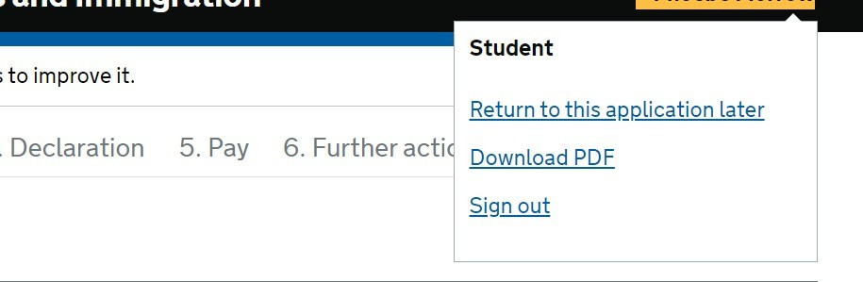

You can save or print a PDF of your application form. You can also sign out, come back and view your application later.

Next steps
If you have used the ‘UK Immigration: ID Check’ app at the beginning of this application, you need to upload your supporting document by logging back into your UKVI application account.

If you were unable to use the app for the visa application, you need to register for the UKVCAS website, upload your documents and make an in-person appointment. At the appointment, you will have your biometric (fingerprints and facial picture) taken. Please take your original passport to your appointment.

Keep log in details.

Keep a copy of your application, document checklist and copy of the documents used to support your application.

Make sure you have constant access to the email address, phone number and UK address stated in your visa application so as not to miss any communications (e.g. additional information/document requests) from UKVI.

When your Student visa is granted
When your visa is granted, you’ll not receive a physical immigration document such as a BRP as these are no longer being printed. What you’ll need to do instead is to create an UKVI account to access your eVisa. Once your eVisa is set up, you can generate a share code as evidence of your immigration status.

Full instructions on eVisa will be included in the UKVI decision letter when your visa application is successful.

You can watch the Home Office videos about how to create an UKVI account and access your eVisa:

- What is an eVisa?
- How to create a UK Visas and Immigration (UKVI) account and get access to your eVisa
- How to prove your immigration status with an eVisa

After having your eVisa set up, you need to log into the UKVI account to check that the visa details are correct. Please see our website information on Visa problems and errors.

More information on Student Visas can be found on the Advice and Counselling Service website

To contact an International Student Adviser please see our website contact page

