SEB Report Generator user guidance
Table of Contents
SEB Report Generator user guidance 1
1.1 Access 1
1.2 Running reports 1
1.3 Associate Student Detail report 3
1.4 Associate Module Detail report 3
1.5 Report types 3
1.6 Report data 4
1.7 Troubleshooting 6

Access
The SEB Report Generator can be accessed at https://webapps-private.its.qmul.ac.uk/seb/.
Username and password are required for generating reports. If you have not yet been given access, please send a request to DGLS at qualityandstandards@qmul.ac.uk.
The data used in the reports is taken directly from SITS. Please note that the data is updated hourly and while the update process is ongoing report generation does not work correctly. It is therefore advised to not run reports until 10 minutes past the hour.
The automated updates will be run daily between 06.00 and 22.00 during the exam board period. If you have, exceptionally, received prior agreement for your board to take place outside of the official exam board period, you will need to contact the Data Quality Team to request for the data to be updated.

Running reports
The Choose Option menu on the left-hand side lets you choose the type of report to generate.
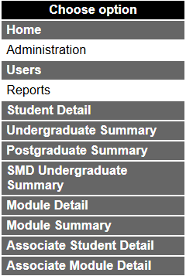
By clicking on a report type you can view information about the file format and content, as shown in the example below.
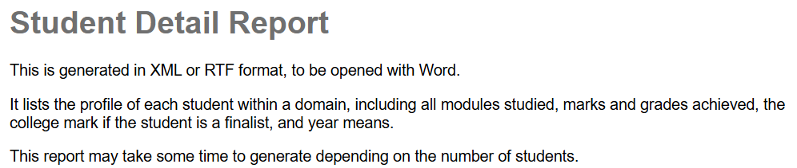
Below the description you will see the information fields that you will need to fill in for generating a report. An asterisk (*) marks the required fields.
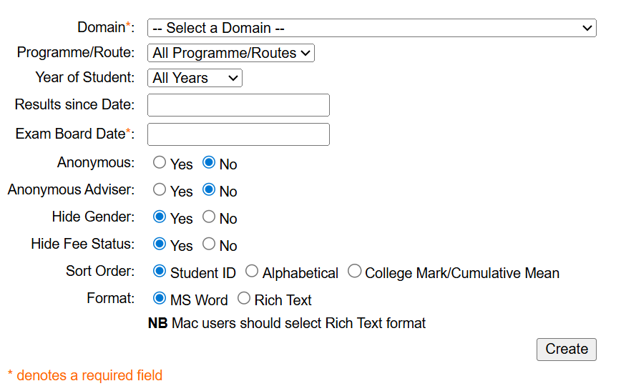
To generate the report:
- Select domain from the drop-down menu.
- By default, all programmes/routes are included. If you wish to generate a report only for a specific programme/route select it from the drop-down menu.
- By default, all years of study are included. For large SEBs it may be useful to generate separate reports for different year groups. If you wish to do so, please select the year from the drop-down menu.
- Enter a date in the format dd/mm/yyyy.
- Check you have completed all the required fields (marked with *) and then click Create to generate the report if you are happy with the default settings. If not, the remaining fields allow you to make optional choices
  - Choose whether to hide or display
    - student names (anonymous vs. non-anonymous).
    - advisor names.
    - gender.
    - fee status.
  - Define sort order (for Student Detail only).
  - Choose file format (for Student Detail only).
The specific fields vary depending on the report type but the steps to follow are the same: fill in required fields and then click Create to generate the report. More detailed guidance is given below for the Associate student reports.

Associate Student Detail report
- Log in to the SEB Report Generator.
- Select the report type Associate Student Detail from the Choose option menu.
- Choose Associate Programmes (American) Dummy (QM015) as the Domain (from the drop-down menu).
- Fill in date in the format dd/mm/yyyy and click Create to generate a report with all associate students or, if you wish to narrow down to particular school/department or programme, follow steps 5 and 6.
- Choose Programme/Route field has several options:
- Click on the desired option to select one individual programme, or
- Use the Shift key to select a group of programmes listed continuously, or
- Use the Control key to pick up individual programmes from the list
- Select the school or department from the Show modules drop-down menu.
- Fill in date in the format dd/mm/yyyy.
- Click Create to generate the report.

Associate Module Detail report
- Log in to the SEB Report Generator.
- Select the report type Associate Module Detail from the Choose option menu.
- Choose Associate Programmes (American) Dummy (QM015) as the Student Domain (from the drop-down menu).
- Module Domain field offers different options:
- Select All Domains to generate a report including associate students from all schools/institutes with separate sheets for each school/institute and level.
- Select the desired school and level from the drop down menu.
- Fill in date in the format dd/mm/yyyy.
- Click Create to generate the report.

Report types
The table below describes the different report types used by SEBs.
Please note that it works best to first save the report in .docs/.xlsx and then open with either Excel or Word (as indicated in the table below) before reviewing or annotating.
Report type | Format | Open with | Content
Associate Module Detail | XML | Excel | Lists by Domain the modules taken by Associate students including student marks and grades achieved down to individual assessments
Associate Student Detail | XML / RTF | Word | Lists the profile of each student within a domain, including all modules studied, marks and grades achieved down to individual assessments.
Module Detail |  | Excel | Provides the assessment and module marks for students on particular modules for the current academic year or a specific time period. It also provides some statistics; the failure rate, grade distribution, and average marks.  There are 3 worksheets for each occurrence of the module:  - Header page gives a summary of the module and its assessments.  - Actual Report lists each student registered on the module, and the marks and grades achieved at assessment and overall module level.  - Failure Rates & Grade Distribution provides analysis on the failure rates of the module and grade distribution.
Module Summary |  | Excel | Provides an overview of module grade distribution and average marks by level for a specified number of academic years.  There are 2 worksheets:  - Analysis of module results for students who have completed at attempt 1.  - Analysis of modules results for students who have completed at resit.  Students who are yet to complete, e.g. waiting to resit or on hold due to extenuating circumstances or academic misconduct, will not be included in the report.
Student Detail | XML / RTF | Word | Lists the profile of each student within a domain, including all modules studied, marks and grades achieved, the college mark if the student is a finalist, and year means.
Postgraduate Summary | XML | Excel | Provides an overall summary of students and the number of credits they have passed, and average marks across taught and project/dissertation modules. It also includes the number of credits that have a mark of less than 40 and less than 30.  There are 2 worksheets:  - First sits.  - Resits (students resitting out of attendance).
SMD Undergraduate Summary | XML | Excel | Provides an overall summary of students and the modules they have taken. Designed specifically for FMD exam boards.
Undergraduate Summary | XML | Excel | Provides an overall summary of all students and the number of credits they have passed per year and the yearly averages.

Report data
The table on the next page explains the report fields most relevant for the SEBs.
Field | Description
Actual Class | This is left blank for the Board to decide.
ADV | This field indicates whether the student has transferred in any advanced standing credits.
Agreed Decision | This is left blank for the Board to decide.
Agreed Progress | This is left blank for the Board to decide.
Classification Mark | This will only be displayed for those students who are eligible for award.
Credits passed | This is the total sum of all credits passed by the student
Credits taken | This is the total sum of all credits taken by the student.
Credits < 30 | This is the total sum of credits where the mark achieved is less than 30
Credits < 40 | This is the total sum of credits where the mark achieved is less than 40
EC | This indicates whether the student has submitted an EC claim. This is taken from the marks/grades entered.
Module Results | These are sorted by academic year and by mark/grade.  If the TMR process (module lockdown run by Registry Services) has not yet run for this module, then only the actual marks will be displayed.
Module status | COM: completed, either successful completion, or student has run out of attempts.  RAS: student is currently in resit as they still have attempts remaining  SAS: module has not been TMR’d – this could be due to marks not yet entered, overall module mark not yet calculated, or just that the TMR process still needs to run for it.
Notes | This is left blank as a space for you to make any notes as necessary.
Project Average | This is the mean of marks for modules that are classed as a Project.
Recommendations | The Recommended Progress code, Classification Mark or Recommended Award Class will only be displayed if the Progression process has been run for the student.
Recommended Award | This is the recommended award. If the student has been recommended for an exit award, the award code will begin with X.
Recommended Class | This is the calculated classification.
Recommended Decision | This is the progress code that the system has calculated for the student.
Recommended Progress | This is the progress code that the system has calculated for the student.
Results Summary | A summary of the grades and the credits taken and passed, split into development years.
Retake | This indicates whether any of the modules are retake modules.
Status | This is the current enrolment status of the student. Some of the more common ones are R-E-E (fully enrolled), R-R-R (Resitting out of attendance), R-I* (Interrupting studies).
Taught Average | This is the mean of marks for taught modules.
Tutor | This is the student’s personal tutor. If no tutor has been assigned, then N/A will appear.
Y1 Average | This is the mean mark of all the modules taken in the first development year.
Y2 Average | This is the mean mark of all the modules taken in the second development year.
Y3 Average | This is the mean mark of all the modules taken in the third development year.
Year Mean calculations | These calculations do not take into account any modules which are Transcriptable Only or Study Only.

Troubleshooting
Q: I have entered marks in SIS but they’re not appearing on my SEB report.
A: This could be due to a number of reasons.
Check that the entered marks have been TMR’d. This means that the marks have been locked down which enables the report to pick them up. If you have run the Student Detail report and the marks are appearing under the Actual Marks section but not the Agreed marks section and the Module Status is still SAS, then this is certainly the case. You need to contact Registry Services and ask them to TMR the marks for you.
The refresh of data may not yet have happened to pick up your marks. The data in the SEB reports is refreshed on an hourly basis each day between 06.00 and 22.00. If your data has only recently been TMR’d, then you will need to wait for the next refresh for this to be picked up in the SEB report.
You may have entered in the assessment marks without then calculating the overall module result. If this step hasn’t been completed, then the TMR process cannot lock down the marks. You will need to run the Calculate module marks option on the Mark Entry screen and then contact Registry Services for the data to be TMR’d.
Q: A student isn’t appearing in the report
A: Check that the student has an active status and is registered for the programme in MySIS. If they are no longer an active student, then they will not appear on the report. Only students with an active status (this includes resitting out of attendance students and students on an interruption) will be picked up in the report.
Q: The marks have been updated and the results TMR’d but the progression status hasn’t changed.
A: Double check that the changes to the marks will actually lead to a new progress code. If yes, then it could be that the progression code has not been regenerated following TMR. Check with Registry Services. If they need to re-run progression, then you will need to wait for the hourly refresh for this to be picked up in the report.

