AHRC Collaborative Doctoral Partnership (CDP) studentship
Inner Wear: Domestic Dress and Clothing Practices in the English Home (1870-2019)
Queen Mary University of London with the Museum of the Home
Deadline for applications is: 1700 BST, Monday 22 June 2026
Interviews will be held during the week commencing: Monday 13 July 2026
Queen Mary University of London and the Museum of the Home are pleased to announce the availability of a fully-funded Collaborative Doctoral Studentship from October 2026 under the AHRC’s Collaborative Doctoral Partnership (CDP) scheme. The studentship is funded for four years full-time, or up to eight years part-time.
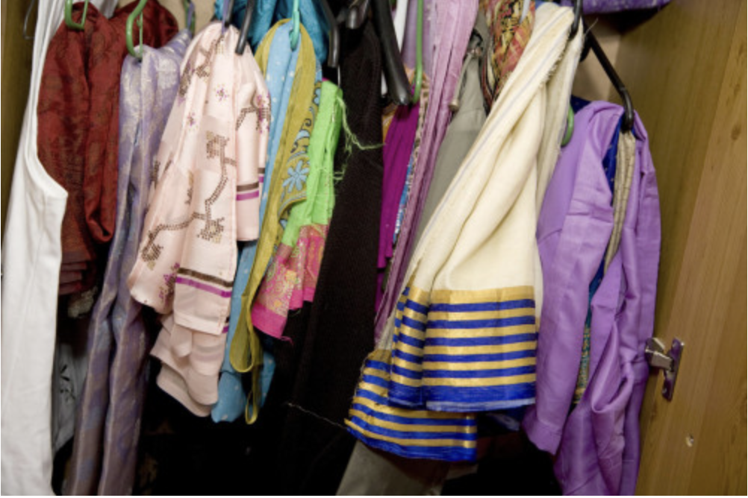
© Marysia Lachowicz, Documenting Homes collection, Museum of the Home, London.

Project overview and key aims
This project explores the shifting clothing practices and ways in which people have dressed in English homes in the period 1870-2019. Focusing on both specific garments as well as the gestures, routines, places, and objects involved with the act of dressing, the project aims to provide a fuller sense of embodied experiences of home, and to increase understanding of domestic clothing practices, including similarities with museological processes.
Drawing on sources including catalogues, garments, photograph albums, home video, (un)published autobiographies, memoirs and diaries, television series, and literary texts, it examines the role of domestic clothing in identity construction and the emotional, physical and psychological impact of clothing practices in the home – from comfort to distress and overwhelm. ‘Inner Wear’ encompasses the mundane everyday but also – because of practices like fancy dress and house parties – the more fantastical and outlandish. It extends beyond the usual focus on women and girls to include men and boys and beyond individual acts of dress to consider the dressing of others.
Alongside a PhD thesis presenting original new research, the project will contribute to the Museum of the Home’s assessment of its clothing collection and the ways in which it can be deployed and engage audiences in new ways, both in the period rooms and in learning and public programming initiatives. A tailored report, evening event focusing on house parties, and podcast series/online exhibition are examples of ways the research could assist museum staff and bring the key findings to a wider audience.
This project will be jointly supervised by Kiera Vaclavik (Professor of Children’s Literature & Childhood Culture), and Aoife Monks (Professor of Cultural & Creative Industries) at Queen Mary; and, at the Museum of the Home, by Ailsa Hendry (Collections Manager) and Hannah Gardner Seavey (Commercial Programme Manager).
Funded period, fees and stipend
The studentship is funded for four years full-time, or up to eight years part-time.
Award provides full fees and maintenance at the UKRI rate (£21,805 in Session 2026/27), a London allowance of £1,000 per annum plus a £600 enhancement per annum, a research training support grant and other allowances (pro rata for part-time study).
You will be expected to spend time at both QMUL and the Museum of the Home, as well as becoming part of the wider cohort of CDP funded students across the UK.

Eligibility
- You need to have, or will have, a Masters degree or equivalent relevant experience by the time the studentship starts and meet the English language requirements.
- You also need to meet the AHRC’s UK residency requirements. (Full details are in the ‘Training Grant Funding Guide’ available on the AHRC’s website at: https://www.ukri.org/files/legacy/publications/rcuk-training-grant-guide-pdf/, and which should be read alongside the ‘Terms and Conditions of RCUK Training Grants’ and the ‘RCUK Training Grant Guide’, both available at the RCUK website (see https://www.ukri.org/funding/information-for-award-holders/grant-terms-and-conditions/) and The Education (Fees and Awards) (England) Regulations 2007.
- EU citizens who do not meet these residency requirements can apply, but are only eligible for an award that pays tuition fees only and not money to cover living expenses.
- For queries about eligibility for funding under the AHRC CDP programme, prospective students should consult the RCUK’s Terms and Conditions of Research Council Training Grants in the first instance, or contact the admissions office of the HEI to which they will be applying to undertake the PhD.

Applicant Webinar and more information
On Monday 13 April 2026 AHRC hosted a webinar for potential applicants exploring the CDP Scheme and how the funding and application process works.
If you would like to catch up with the applicant webinar you can do so on the following link – https://youtu.be/ALgblgLBPLc
More information and FAQs about CDPs are available here: https://www.ahrc-cdp.org/faqs/

For enquiries, or an informal discussion, please contact
Kiera Vaclavik (k.e.vaclavik@qmul.ac.uk)
If you meet the requirements please submit your application from this link, https://www.qmul.ac.uk/postgraduate/research/applying-for-a-research-degree/

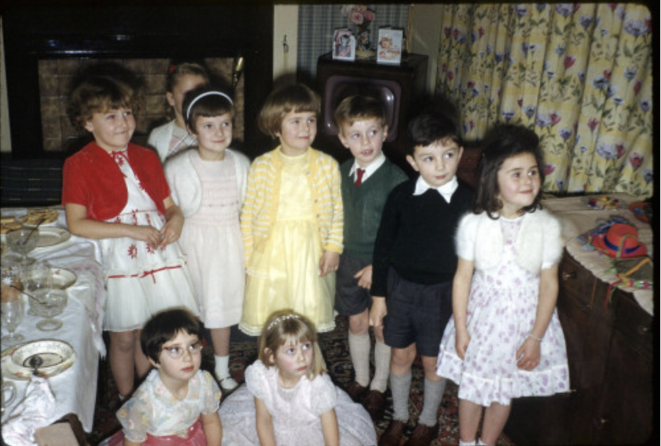
© Andrea and Robin Scagell, Documenting Homes collection, Museum of the Home, London.

